**Physical Development:**

- **Rainbow bubble snake (EAD/ CL/ PSED):** Enjoy this fun outdoor activity making bubble snakes. Instructions follow below.

https://www.twinkl.co.uk/resource/us-t-327-rainbow-bubble-snake-science-experiment

**Communication and language:**

- **Healthy/ unhealthy food collage (PD/ EAD/ UTW):** Use the following worksheet to talk to your child about how healthy foods are goof for us and how unhealthy foods are not good for us. Get you child to cut out the foods and group them into healthy and unhealthy.

https://www.twinkl.co.uk/resource/t-t-2399-healthy-eating-lunch-activity

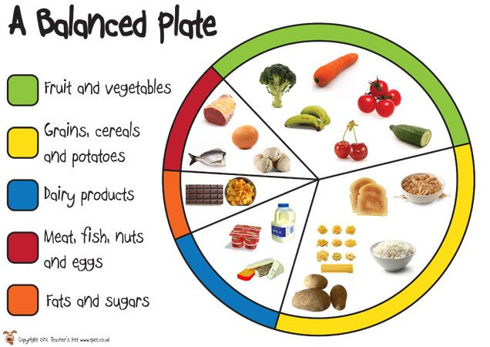

**Personal, social, and emotional development**

- **Food tasting (UTW/ PD/ CL):** Try out different fruit, veg and foods and give them s like or dislike. Get the whole family to try something new.

https://www.twinkl.co.uk/resource/t2-p-285-cfe-early-level-food-tasting-activity-sheet

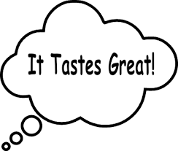

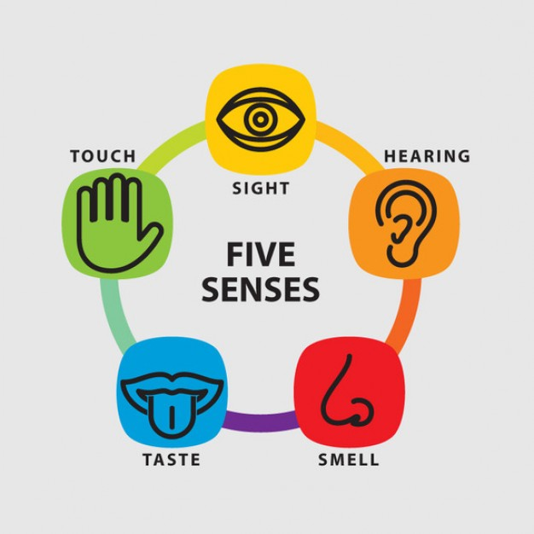

**Week 4 (22/06/20)**

