**Communication and language:**

- ‘**I spy’ (UTW/ EAD/ PD):** Teach your child how to play ‘I spy’ if it’s easier use sounds (car, favourite toy etc.) to play the game.

- **‘My five senses’ (L/ PD/ PSED):** Read the story ‘My five senses and speak to your child about senses and what we use them for.

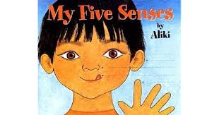

**Physical Development:**

- **Let’s make orange juice (UTW/ CL/ PSED):** Help your child to juice 3 oranges for one glass of orange juice (add juice of ¼ lemon and some sugar if you like). Talk about what we use to taste different things and maybe try some new fruits and veg.

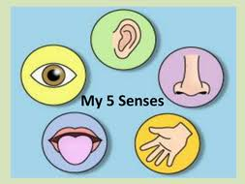

**Week 3 (15/06/20)**

**Personal, social, and emotional development**

- **Textured playdough (PD/ EAD/ CL/ EAD):** Make playdough of different textures by adding pasta or rice or sand and different scents. Ask your child about how it feels and smells, talk about different textures around us. Encourage family members and siblings to join.



